CS333

Luis Cervantes Oropeza

**Compilation Test:**

Subtest 1:

Compile with CS333_PPROJECT set to PRINT SYSCALLS set to 0 and CS333 PROJECT set to 0 in the Makefile

(a) Code correctly compiles **(Passes)**

(b) No trace information is displayed **(passed)**

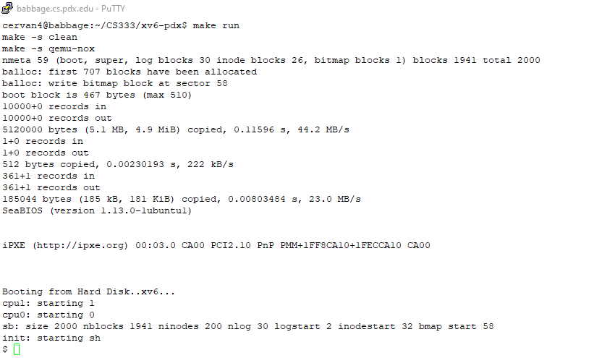

Subtest 2:

Compile with the PRINT SYSCALLS set to 1 and CS333 PROJECT set to 0 in the Makefile

(a) Code correctly compiles **(Passes)**

(b) Tracing facility works correctly **(Passes)**

(c) Correct system call trace on boot **(Passes)**

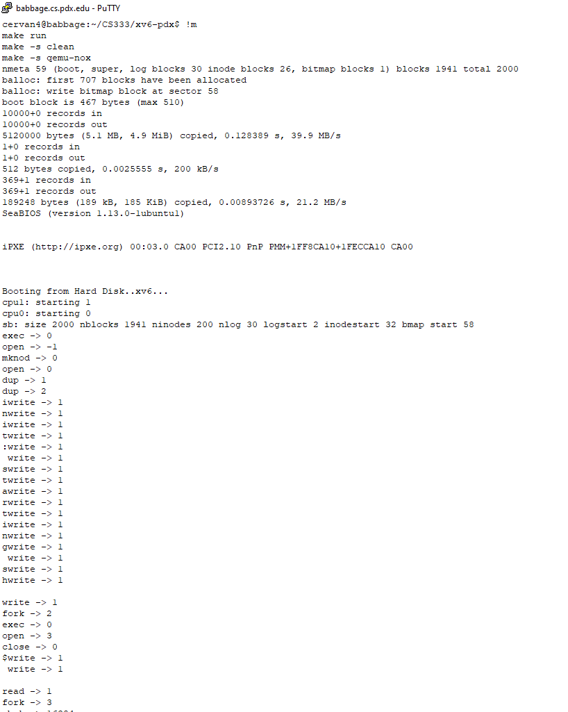

**Subtest 3:**

with the CS333 P1 macro turned off, when CS333 PROJECT is set to 0 in the Makefile

(a) Test program forktest runs correctly **(Passes)**

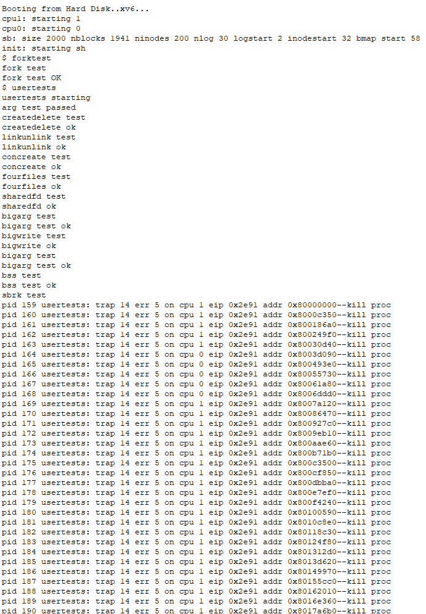(b) Test program usertests runs correctly **(Passes)**

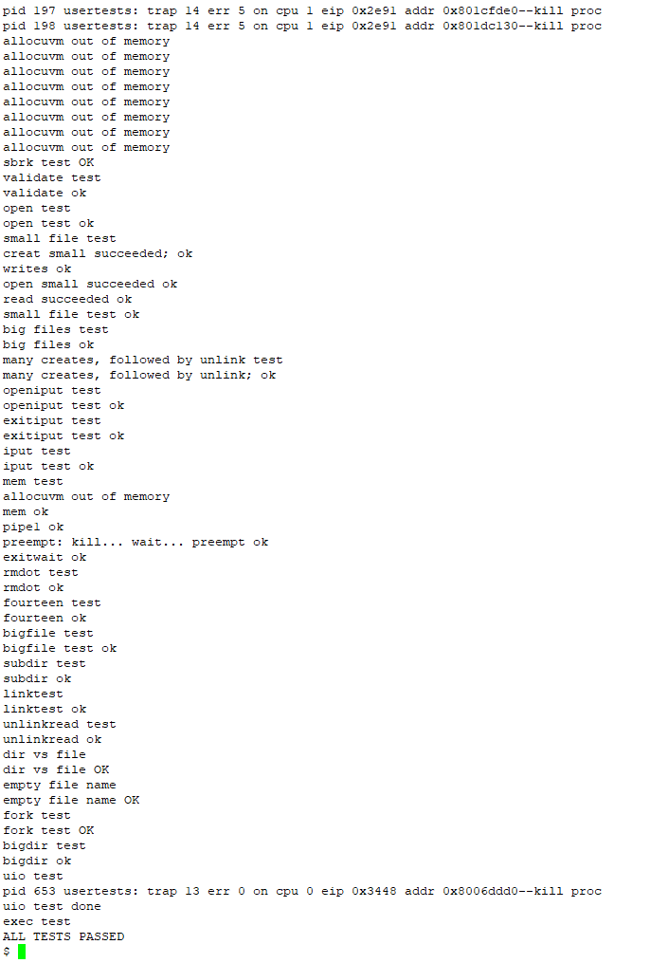

Subtest 4:

The CS333 P1 macro turned on, when CS333 PROJECT is set to 1 in the Makefile

(a) Test program forktest runs correctly **(Passes)**

(b) Test program usertests runs correctly **(Passes)**

(c) The date command prints correct information **(Passes)**

(d) The date command prints information in the correct format **(Passes)**

(e) The following test shows that the date command and the Linux date command provide basically the same information. (i.e. Run date command in xv6 → Exit xv6 → Run date command from linux prompt → Compare ouput) (Passes)

(f) Control – P **(Passed)**

i. Displays correct header

ii. Data aligns with appropriate header i

ii. Correct data is displayed

Forktest and usertests test

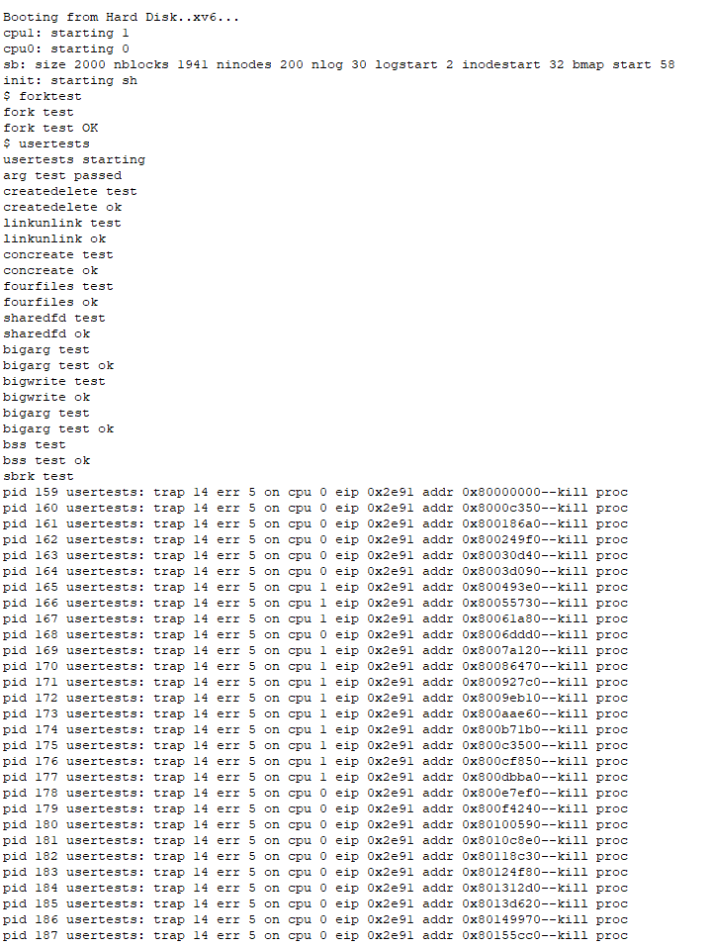

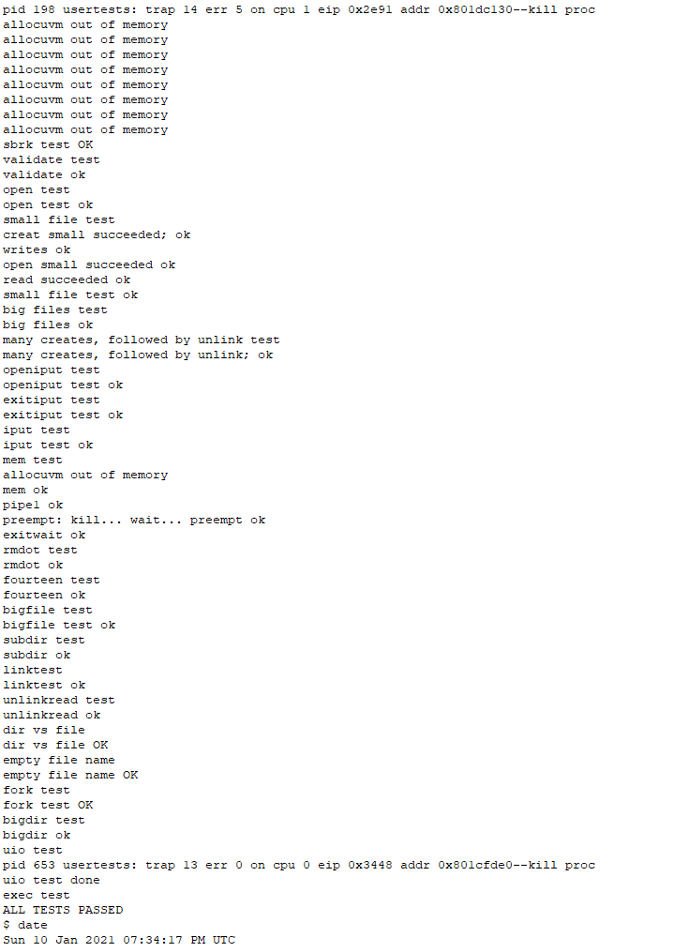

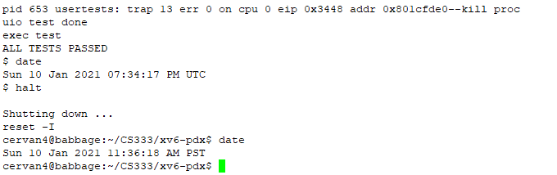

While I was in Xv6 the date was in UST time zone while in Linux it was on PST

Control -P Test

